Type the title of your paper here
First and last name of each author in Times New Roman font type, 11 point bold, for example: Aniela Bălăcescu¹, Jhon Taylor² and Anamaria Popescu²
¹Faculty of Economics, Constantin Brancusi University of Targu Jiu, Romania, ORCID: 0000-0002-2937-4917
²Mechatronics Faculty, California State University, Los Angeles, UK, ORCID: …..
³Faculty of Engineering, Transilvania University of Braşov, Romania, ORCID: ….

E-mail: anielabalacescu@gmail.com
Abstract. All articles must contain an abstract. The abstract text should be formatted using 10 point Times or Times New Roman and indented 25 mm from the left margin. Leave 10 mm space after the abstract before you begin the main text of your article, starting on the same page as the abstract. The abstract should give readers concise information about the content of the article and indicate the main results obtained and conclusions drawn. The abstract is not part of the text and should be complete in itself; no table numbers, figure numbers, references or displayed mathematical expressions should be included. It should be suitable for direct inclusion in abstracting services and should not normally exceed 200 words in a single paragraph. Since contemporary information-retrieval systems rely heavily on the content of titles and abstracts to identify relevant articles in literature searches, great care should be taken in constructing both.
Keywords: 4-8 keywords separated by commas (Times 10 pt, Italic).

Introduction
These guidelines, written in the style of a submission to Journal of Research and Innovation for Sustainable Society, show the best layout for your paper using Microsoft Word. If you don’t wish to use the Word template provided, please use the following page setup measurements: A4 only, Margins: Top-4.0 cm; Bottom-2.7 cm; Left-2.5 cm; Right-2.5 cm; Gutter-0 cm; Header-0 cm; Footer-0 cm.
It is vital that you do not add any headers, footers or page numbers to your paper; Also, the article, tables, figures, references and appendices included, should be 4-20 pages long, an even number of pages is compulsory. The last page will be filled at least 70%. Manuscripts that are more than 20 pages will be returned to the author for revision before review.
Formatting the title, authors and affiliations
Please follow the template as carefully as possible so all articles within a conference have the same style to the title page. This paragraph follows a section title so it should not be indented.
Subsequent paragraphs should be indented by 5 mm.
  - Formatting the title
The title is set 17 point Times Bold, flush left, unjustified. The first letter of the title should be capitalized with the rest in lower case. It should not be indented. Leave 28 mm of space above the title and 10 mm after the title.
  - Formatting author names
The list of authors should be indented 25 mm to match the abstract. The style for the names is initials then surname, with a comma after all but the last two names, which are separated by ‘and’. First names in full may be used if desired. If an author has additional information to appear as a footnote, such as a permanent address or to indicate that they are the corresponding author, the footnote should be entered after the surname.
  - Formatting author affiliations
Please ensure that affiliations are as full and complete as possible and include the country. The addresses of the authors’ affiliations follow the list of authors and should also be indented 25 mm to match the abstract. If the authors are at different addresses, numbered superscripts should be used after each surname to reference an author to his/her address.
Formatting the text
The text of your paper should be formatted as follows:
- 11 point Times or Times New Roman.
- The text should be set to single line spacing.
- Paragraphs should be justified.
- The first paragraph after a section or subsection heading should not be indented; subsequent paragraphs should be indented by 5 mm.
Sections, subsections and subsubsections
The use of sections to divide the text of the paper is optional and left as a decision for the author. Where the author wishes to divide the paper into sections the formatting shown in table 2 should be used.
  - Style and spacing
Table 1. Formatting sections, subsections and subsubsections.
 | Font | Spacing
Section | 11 point Times bold | 1 line space before a section  No additional space after a section heading
Subsection | 11 point Times Italic | 1 line space before a subsection  No space after a subsubsection heading
Subsubsection | 11 point Times Italic | Subsubsections should end with a full stop (period) and run into the text of the paragraph
  - Numbering
Sections should be numbered with a dot following the number and then separated by a single space:
- sections should be numbered 1, 2, 3, etc
- subsections should be numbered 2.1, 2.2, 2.3, etc
- subsubsections should be numbered 2.3.1, 2.3.2, etc
Figures
Each figure should have a brief caption describing it and, if necessary, a key to interpret the various lines and symbols on the figure.
  - Space considerations
Authors should try to make economical use of the space on the page; to avoid excessively large white space borders around your graphics; try to design illustrations that make good use of the available space—avoid unnecessarily large amounts of white space within the graphic;
  - Text in figures
Wherever possible try to ensure that the size of the text in your figures (apart from superscripts/subscripts) is approximately the same size as the main text (11 points).
  - Line thickness and color illustrations
In general, try to avoid extremely fine lines because such lines often do not reproduce well when printed out—your diagrams may lose vital information when downloaded and printed by other researchers. Try to ensure that lines are no thinner than 0.25 pt. Note that some illustrations may reduce line thickness when the graphic is imported and reduced in size (scaled down) inside Microsoft Word.
You are free to use colour illustration.
  - Positioning figures
Individual figures should normally be centred but place two figures side-by-side if they will fit comfortably like this as it saves space. Place the figure as close as possible after the point where it is first referenced in the text. If there are a large number of figures it might be necessary to place some before their text citation. Figures should never appear within or after the reference list.
  - Figure captions/numbering
Captions should be below the figure and separated from it by a distance of 6 points—although to save space it is acceptable to put the caption next to the figure. Figures should be numbered sequentially through the text—‘Figure 1’, ‘Figure 2’ and so forth and should be referenced in the text as ‘figure 1’, ‘figure 2’,… and not ‘fig. 1’, ‘fig. 2’, ….
For captions not placed at the side of the figure, captions should be set to the width of the figure for wider figures, centred across the width of the figure, or, for narrow figures with wide captions, slightly extended beyond the width of the figure. The caption should finish with a full stop (period).
  - Figures in parts
If a figure has parts these should be labelled as (a), (b), (c) etc on the actual figure. Parts should not have separate captions.
  - Example
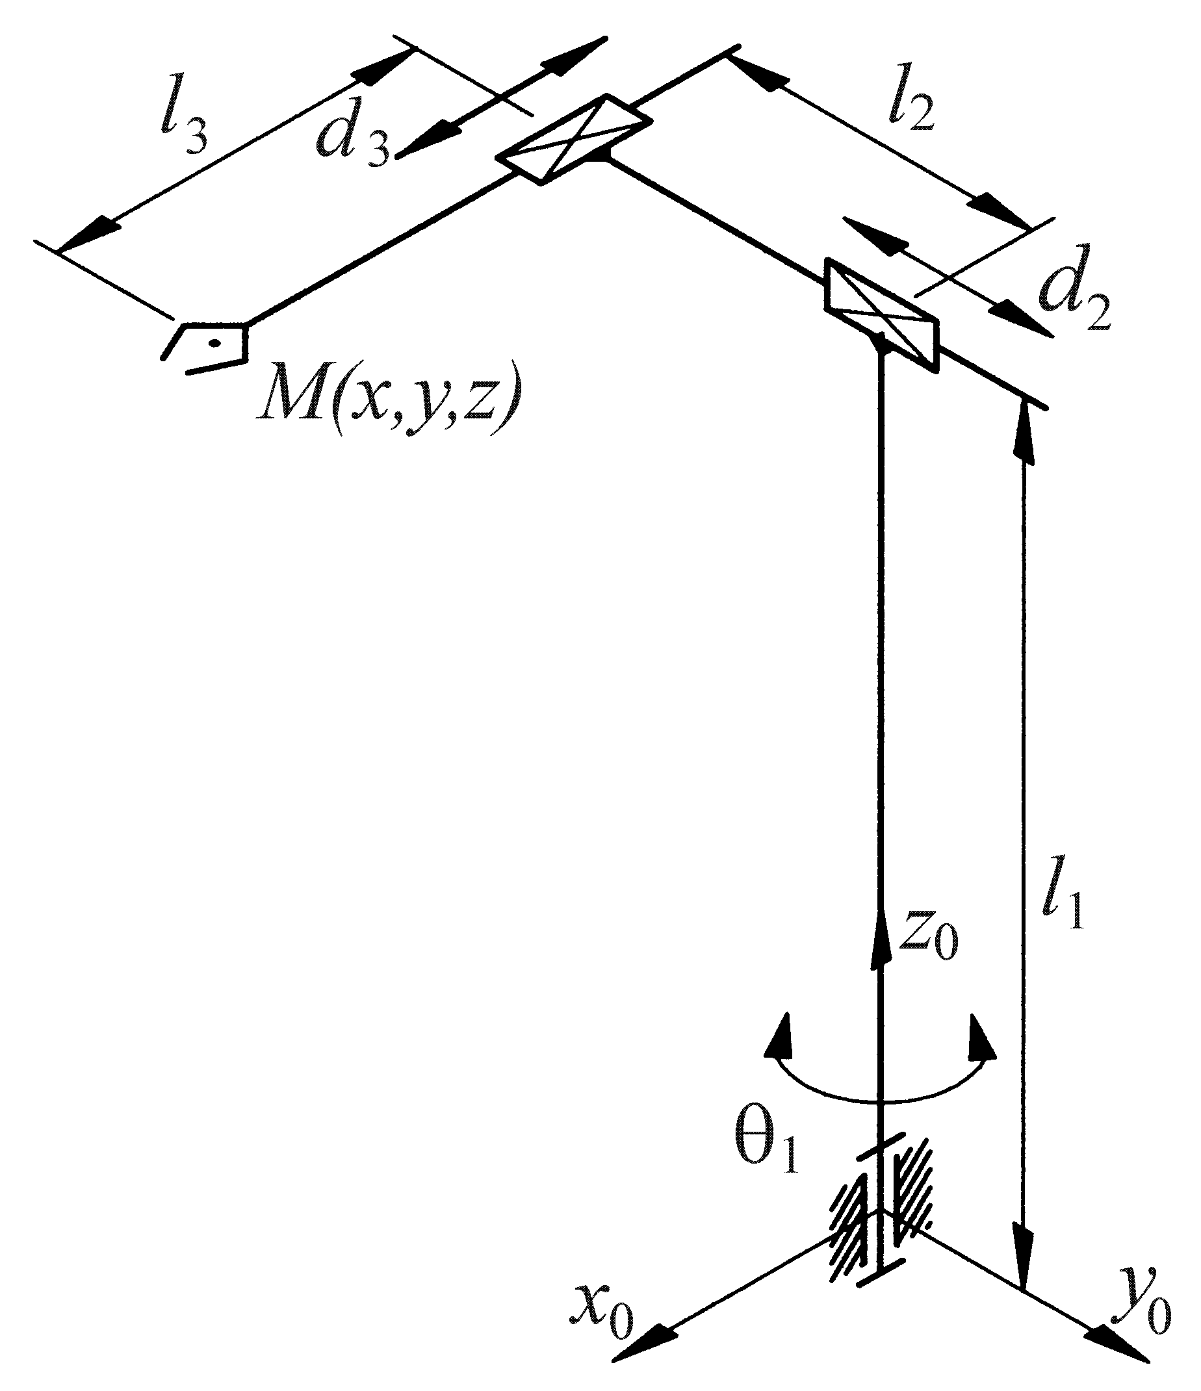
Figure 1. Figure example.
Tables
Note that as a general principle, for large tables font sizes can be reduced to make the table fit on a page or fit to the width of the text. Tables should be centred unless they occupy the full width of the text. If a table is divided into parts these should be labelled (a), (b), (c) etc but there should only be one caption for the whole table, not separate ones for each part. Tables should be numbered sequentially throughout the text and referred to in the text by number (table 1, not tab. 1 etc). Captions should be placed at the top of the table and should have a full stop (period) at the end. Except for very narrow tables with a wide caption the caption should be the same width as the table.
Tables should have only horizontal rules and no vertical ones. Generally, only three rules should be used: one at the top of the table, one at the bottom, and one to separate the entries from the column headings. Table rules should be 0.5 points wide.
Equations and mathematics
  - Fonts in Equation Editor (or MathType): Make sure that your Equation Editor or MathType fonts, including sizes, are set up to match the text of your document.
  - Vectors. Bold italic characters is our preferred style but the author may use any standard notation; for example, this style for vectors is acceptable:
‘the vector cross product of a and b is given by …’
  - The solidus (). A two-line solidus should be avoided where possible; for example, use
- instead of
- instead of
Please, use the equations settings of the previous example.
  - Alignment of mathematics
The preferred style for displayed mathematics is to centre equations; however, long equations that will not fit on one line, or need to be continued on subsequent lines, should start flush left. Any continuation lines in such equations should be indented by 25 mm.
Equations should be split at mathematically sound points, often immediately before =, + or – signs or between terms multiplied together. The connecting signs are not repeated and appear only at the beginning of the turned-over line. A multiplication sign should be added to the start of turned-over lines where the break is between two multiplied terms.
Some examples:
(1)
(2)
When referring to an equation in the text, always put the equation number in brackets.
Appendices
Technical detail that it is necessary to include, but that interrupts the flow of the article, may be consigned to an appendix included at the end of the main text of the paper, after the acknowledgments section (if any) but before the reference list. If there are two or more appendices they should be called appendix A, appendix B, etc. Numbered equations should be in the form (A.1), (A.2), etc, figures should appear as figure A1, figure B1, etc and tables as table A1, table B1, etc.
References
Online versions of all reference lists will, wherever possible, be linked electronically using CrossRef. Consequently, it is vitally important for all the references to be accurate and to be carefully formatted using the guidelines below, enabling your paper to be available online with the minimum of delay. There should be a 5 mm gap between the reference number (e.g., ‘[1]’) and the start of the reference text. Second and subsequent lines of individual references should be indented by 5 mm.
Examples:

- Waterman B, Owens B, Davey S, Zacchilli M and Belmont Jr P J 2010 The epidemiology of ankle sprains in the United States The Journal of Bone & Joint Surgery 92 pp 2279-2284
- Yoon J, Ryu J and Lim K B 2005 A novel reconfigurable ankle rehabilitation robot for various exercises Proceedings of the 2005 IEEE International Conference on Robotics and Automation ICRA 2005 pp 2290-2295
- Jamwal P K, Xie S and Aw K C 2009 Kinematic design optimization of a parallel ankle rehabilitation robot using modified genetic algorithm Robotics and Autonomous Systems 57 pp 1018- 1027
- Sze S M 1969 Physics of Semiconductor Devices (New York: Wiley–Interscience)

Acknowledgments
Acknowledgments section immediately following the last numbered section of the paper.

